

**DEPARTMENT OF IT/CSE**

**University College of Engineering**

**BIT Campus,Anna University, Tiruchirappalli-24**

**CISCO NETWORKING ACADEMY**

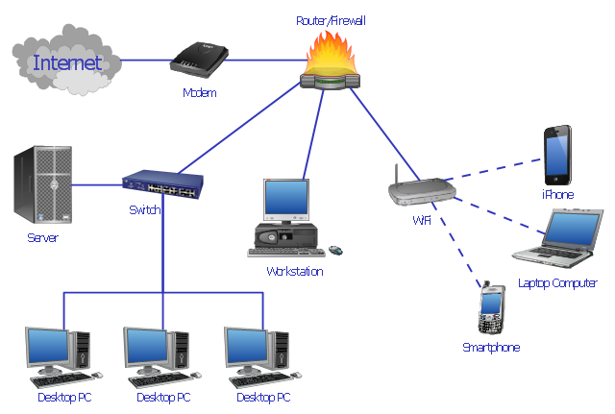**CISCO Networking:**

Cisco Networking Academy, a global education initiative from [Cisco Systems](https://ipfs.io/ipfs/QmXoypizjW3WknFiJnKLwHCnL72vedxjQkDDP1mXWo6uco/wiki/Cisco_Systems.html), offers networking programs, like the (Cisco Certified Network Associate) [CCNA](https://ipfs.io/ipfs/QmXoypizjW3WknFiJnKLwHCnL72vedxjQkDDP1mXWo6uco/wiki/CCNA.html) and (Cisco Certified Network Professional) [CCNP](https://ipfs.io/ipfs/QmXoypizjW3WknFiJnKLwHCnL72vedxjQkDDP1mXWo6uco/wiki/CCNP.html) courses, which prepare students for the certification exams of the same name, and other computer-related courses.

**Networking Essentials** covers basic networking concepts within the context of the networks you encounter every day. In this 70-hour course, students will develop hands-on networking skills and understand the role networks play in our lives. This course introduces students to networking careers and prepares them for further study.

* Learn how to plan and install a network using real equipment and connect it to the Internet.
* Practice verifying and troubleshooting network and Internet connectivity.
* Learn how to recognize and mitigate security threats to a home network.
* Configure common Internet applications, set up sharing between computers, and configure basic IP services.
* Apply skills through practice, using labs and [Cisco Packet Tracer](https://www.netacad.com/courses/packet-tracer-download/) activities.
* Connect with the global Cisco Networking Academy community.

**The CCNA Routing and Switching** curriculum is a gateway to entry-level networking jobs and IT careers. The curriculum consists of 4, 70-hour courses: Introduction to Networks, Routing and Switching Essentials, Scaling Networks, and Connecting Networks. The first 2 courses prepare you for the Cisco CCENT certification exam or to study [CCNA Security](https://www.netacad.com/courses/ccna-security/). All 4 courses are recommended before taking the Cisco CCNA Routing and Switching certification exam.

* Develop a working knowledge of routing, switching, network applications, protocols, and services.
* Study with an instructor in the classroom and access expert content online anytime.
* Practice what you learn on both real equipment and [Cisco Packet Tracer](https://www.netacad.com/courses/packet-tracer-download/), a network configuration simulation tool.
* Get immediate feedback on your work through built-in quizzes and tests.
* Prepare for the workplace with collaborative projects and presentations.
* Connect with the global Cisco Networking Academy community.

**CCNA Introduction to Networks**

**Chapters**

Chapter 1: Explore the Network.

Chapter 2: Configure a Network Operating System.

Chapter 3: Network protocols and Communication.

Chapter 4: Network Access.

Chapter 5: Network Layer.

Chapter 6: IP Addressing.

Chapter 7: Sub netting IP Networks.

Chapter 8: Transport Layer.

Chapter 9: Application Layer.

Chapter 10: Build a Small Network.

**CCNA Routing and Switching**

**Chapters**

Chapter 1: Introduction to Switched Network.

Chapter 2: Basic Switching Concepts and Configuration.

Chapter 3: VLANs Segmentation and Implementation.

Chapter 4: Routing Concepts.

Chapter 5: Inter V-LAN Routing.

Chapter 6: Routing Concepts.

Chapter 7: Static Routing.

Chapter 8: Routing Dynamically.

Chapter 9: Single Area OSPF.

Chapter 10: Dynamic Host Configuration (DHCP).

Chapter 11: Network Address Translation for IPV4.

**Prerequisites:**

* Introduction to Network.

**Software requirements:**

* Cisco Packet tracer 7.0.

**Hardware Components:**

* Cisco Routers (4’s)
* Cisco Switches (4’s)
* Serial cable
* RJ45 Network Ethernet Cables (Cross over and straight through).